
FACULTY OF COMPUTER ENGINEERING, INFORMATICS AND
COMMUNICATIONS
DEPARTMENT OF COMPUTER SCIENCE

TITLE: INDUSTRIAL ATTACHMENT MANAGEMENT SYSTEM
NAME OF STUDENT: TAWANDA KAMHAMBA
REG NO. : R223985C
SUPERVISOR : GOMBIRO
PROG: HCS

THIS CAPSTONE PROJECT IS SUBMITTED IN PARTIAL FULFILMENT OF THE REQUIREMENTS FOR THE BACHELOR HONORS IN COMPUTER SCIENCE

JUNE 2025

Contents
1.1 Introduction 7
1.1.1Current Business Processes 7
1.1.1.1 Educational Institution Processes: 7
1.1.1.2 Host Company Processes: 8
1.1.1.3 Student Processes: 8
1.1.2 Business Rules Governing the Current System 8
1.1.3 Advantages of the Current System 9
1.1.4 Disadvantages and Limitations 9
1.2 Problem Statement. 10
1.3 Proposed Solution 11
1.3.1 Student Portal and Registration System 11
1.3.2 Student Assumptions Submenu 11
1.3.3 Electronic Logbook System 12
1.3.4 Report Submission Portal 12
1.3.5 Company Supervisor Submenu 12
1.3.6 Institutional Supervisor Dashboard 12
1.3.7 Administrative Control Center 13
1.3.8 Notification and Communication System 13
Expected Outcomes 13
1.4 Aims and Objectives 14
1.4.1 Aim 14
1.4.2 Objectives 14
Student Management Objectives: 14
Company Supervisor Submenu: 14
Electronic Documentation Objectives: 14
Institutional Supervisor Objectives: 15
Visit Coordination and Communication Objectives: 15
Administrative Management Objectives: 15
System Performance and Security Objectives: 15
Reporting and Analytics Objectives: 16
Communication and Workflow Objectives: 16
1.5 Project Scope 17
1.5.1 Included Features: 17
1.5.2 Excluded Features: 17
1.5.3 Technical Limitations: 17
1.6 Ethical Considerations 18
1.6.1 Participant Confidentiality: 18
1.6.2 Voluntary Participation: 18
1.6.3 Informed Consent: 18
1.6.4 Data Protection: 18
1.6.5 No Harm Principle: 18
1.6.6 Academic Integrity: 19
1.7 Cost/Budget 20
1.7.1 Hardware and Equipment: 20
1.7.2 Software and Development Tools: 20
1.7.3 Hosting and Services: 20
1.7.4 Research and Documentation: 20
Total Project Budget: $88 20
1.8 Project Plan 21
Phase 1: Research and Planning (Weeks 1-3) 21
Phase 2: System Setup and Basic Development (Weeks 4-6) 21
Phase 3: Core Module Development (Weeks 7-11) 21
Phase 4: Integration and Testing (Weeks 12-13) 21
Phase 5: Final Testing and Documentation (Weeks 14-15) 22
Phase 6: Project Presentation and Submission (Week 16) 22
1.8.2 GANTT CHART 23
2.1 Literature Review 24
2.1.1 The Importance of Industrial Attachment Programs 24
2.1.2 Challenges in Traditional Attachment Management 25
2.1.3 Existing Digital Solutions for Attachment Management 25
2.1.4 Web-Based Student Information Management Systems 26
2.1.5 Information Systems and Organizational Performance 26
2.1.6 Stakeholder Coordination in Experiential Learning 27
2.1.7 Role-Based Access Control in Educational Systems 27
2.1.8 Digital Logbooks and Progress Monitoring 28
2.1.9 Data Analytics for Program Improvement 28
2.1.10 Technology Adoption and User Acceptance 28
2.1.11 Security and Privacy Considerations 29
2.1.12 Summary 29
2.2 Research Methodology 30
2.2.1 Research Approach 30
2.2.2 Development Methodology: Agile Scrum Framework 30
2.2.3 Sprint Structure 31
2.2.4 Data Gathering Methods 32
2.2.5 System Testing Strategy 33
2.3 Resource Requirements 34
2.3.1 Hardware Requirements 34
2.3.2 Software Requirements 34
2.3.3 Hosting and Deployment Resources 36
2.3.4 Communication and Documentation Tools 36
2.4 Functional Requirements 37
2.4.1 Student Portal Functional Requirements 37
2.4.2 Company Supervisor Functional Requirements 38
2.4.3 Institutional Supervisor Functional Requirements 38
2.4.4 Administrator Functional Requirements 39
2.4.5 Communication and Notification Functional Requirements 39
2.5 Non-Functional Requirements 40
2.6 Modelling Diagrams 43
2.6.1 Use Case Diagram 43
2.6.1.1 Primary Actors: 43
44
2.6.2 Overall Use case for the whole System 45
2.6.2 Activity Diagram - Visit Scheduling Process 46
2.6.3 Entity-Relationship Diagram 47
Core Entities: 47
3.1 Class Diagram for Industrial Attachment Management System 48
3.1.1 Class Diagram Explanation 49
3.1.1.1 Core Components: 49
3.1.1.2 Key Relationships: 49
3.2 Object Diagram 49
3.2.1 Object Diagram Explanation 50
3.2.1.1 Current Instance: 50
3.2.1.2 Key Relationships: 50
3.2.1.3 Current Status: 50
3.3 Sequence Diagram: Site Visit Scheduling 51
3.3.1 Sequence Diagram: Site Visit Scheduling(Explanation) 51
3.3.1.1 Key Flow: 51
3.3.1.2 Critical Components: 52
3.3.1.3 Key Features: 52
3.4 Communication Diagram 53
3.4.1 Communication Diagram Explanation 54
3.4.1.1 Key Components: 54
3.4.1.2 Message Flow: 55
3.4.1.3 System Collaboration: 55
3.5 State Diagram 56
3.5.1 State Diagram: Site Visit Lifecycle (Explanation) 57
3.5.1.1 Purpose: 57
3.5.1.2 Key States: 57
3.5.1.3 Critical Transitions: 57
3.6 Process Design 58
3.6.1 State Diagram showing Precondition and Postconditions: Site Visit Scheduling Operation 59
3.6.1.1 Key States: 59
3.6.1.2 Preconditions Govern: 59
3.6.1.3 Postconditions Define: 59
3.6.1.4 Error Handling: 59
References 60

CHAPTER 1: PROJECT PROPOSAL

1.1 Introduction
The student industrial attachment has become an integral part of academic programs that seek to improve students’ career prospects and employability. Industrial attachment programs serve as a critical bridge between academic learning and professional practice, requiring coordination among multiple stakeholders including educational institutions, host companies, students, and
supervisors. For the employers, the program bridged the gap between theory and practice while academics viewed attachment as helping clarify career objectives as well as enhancing job opportunities for the students. In turn, Leslie (1991) further outlines the following benefits of
student attachments: giving students broader knowledge through increased awareness of the opportunities available, the diversity of the industry, and personal development. Davies (1990) traces the origins of industrial attachment to the Second World War and states that the main
reason was to bridge the gap between skills demands by industry and the content of traditional undergraduate courses in the advent of technological advances. Currently, most educational
institutions manage these programs through traditional, manual processes that have been established over decades of academic practice.

1.1.1Current Business Processes

1.1.1.1 Educational Institution Processes:

- Student application processing through physical forms and manual review (Students upload CVs on Google drive.)
- Manual assignment of students to available company placements
- Paper-based documentation of placement agreements and contracts
- Periodic supervisor visits scheduled through phone calls, WhatsApp, or emails
- Manual compilation of student progress reports and assessment forms
- Physical filing and storage of attachment documentation
- End-of-program evaluation through paper-based feedback forms

1.1.1.2 Host Company Processes:

- Receiving student applications through institutional representatives
- Manual orientation and onboarding of attachment students
- Supervisor assignment based on departmental availability
- Progress monitoring through informal check-ins and verbal feedback
- Completion of assessment forms using paper-based evaluation sheets
- Communication with institutions through phone calls or occasional emails

1.1.1.3 Student Processes:
- Submission of attachment reports in physical format
- Direct communication with company supervisors for guidance
- Completion of logbooks and reflection journals manually
- Final presentation preparation with limited institutional support (Industrial Projects.)

1.1.2 Business Rules Governing the Current System
- Students must complete a minimum number of attachment Months as specified by the academic program.
- Institutional supervisors must conduct at least two site visits during the attachment period.
- Host companies must assign a qualified supervisor with relevant industry experience.
- Students must submit industrial reports to both institutional and company supervisors.
- Final assessment requires input from both institutional supervisors and company mentors.
- All documentation must be submitted within specified deadlines for academic credit.

1.1.3 Advantages of the Current System
The existing manual system offers certain benefits including direct personal interaction between supervisors and students, flexibility in handling unique situations, established relationships
between institutions and host companies, and minimal technology requirements that ensure accessibility across different organizational contexts.

1.1.4 Disadvantages and Limitations
However, the current system presents significant challenges that compromise program
effectiveness. Manual processes lead to time-consuming administrative tasks, increased risk of document loss or misplacement, difficulty in tracking student progress across multiple
placements, inconsistent communication between stakeholders, limited data collection for program improvement, and challenges in generating comprehensive reports for accreditation or quality assurance purposes. Additionally, the system lacks real-time visibility into placement status, making it difficult for institutions to identify and address problems promptly.
These operational inefficiencies create bottlenecks in program management, reduce the quality of student supervision, and limit the ability of institutions to demonstrate program outcomes to
stakeholders and accreditation bodies, necessitating a more integrated and efficient approach to industrial attachment management

1.2 Problem Statement.
Educational institutions managing industrial attachment programs face critical challenges due to fragmented, manual systems that fail to provide comprehensive oversight of student placements. Key issues include inadequate tracking of supervisor visits and student assignments, insufficient documentation of skills development and performance assessments, poor visibility into
placement statistics and resource allocation, limited mechanisms for collecting company
feedback, and fragmented communication processes between students, institutional supervisors, and host companies. These systemic problems result in sub-optimal learning experiences for students, frustrated industry partners, and institutions struggling to demonstrate program
effectiveness and maintain quality standards, creating an urgent need for an integrated web-based management system that can track, monitor, and coordinate all aspects of the industrial
attachment process. Sulaiman et al., (2022) said that many students register for the Industrial Training every semester and the total number of students keep increasing semester by semester, therefore the amount of data to be recorded has also increased and due to this, the process of
collecting, keeping, and retrieving data could be tedious and time-consuming when they are done manually.

1.3 Proposed Solution
An online platform for the industrial training students must be prepared where they can share their learning along with problems associated with various tasks of industrial training” (Kukreti & Dani, 2020). The Industrial Attachment Management System is a web-based platform
designed to address the identified challenges through role-based functionality that streamlines industrial attachment management for all stakeholders. The management of Information systems plays a significant role in contributing to the success of an organization's performance through a set of procedures and functions (Hasan, 2018). Effective record-management systems can assist an organization to run smoothly, including universities to manage large volumes of data and
ensure the reliability of their records within a framework (Kemoni and Wamukoya, 2000). The system provides distinct interfaces and workflows for students, institutional supervisors, company supervisors, and administrators.

1.3.1 Student Portal and Registration System
Students will access the system using their institutional registration numbers and secure passwords. Upon login, students will access a comprehensive dashboard with dedicated
submenus for all attachment-related activities. The Instructions Page provides clear guidelines for all system processes, ensuring students understand requirements and procedures. Through the Registration Submenu, students can register their attachment type, selecting between
institutional attachments or external industry placements, with appropriate forms and requirements for each category.

1.3.2 Student Assumptions Submenu
The Student Assumptions Submenu enables students to register their personal details and specify the companies they are attached to, including company information, supervisor details, and attachment duration. This also includes the submission of Student contracts and also onboarding orientation forms. This creates essential linkages between students and their placement organizations for tracking and coordination purposes.

1.3.3 Electronic Logbook System
The E-Logbook Section provides students with digital tools to record daily tasks and activities throughout their attachment period. Students will document their daily experiences, learning outcomes, and task completion, with the system requiring weekly submission of logbook entries for supervisor review. The digital format ensures consistent documentation and eliminates the risk of lost or damaged physical logbooks.

1.3.4 Report Submission Portal
Through the Report Submission Submenu, students can upload their comprehensive final attachment reports in digital format. The system will support multiple file formats and provide version control, ensuring secure storage and easy access for supervisors during evaluation processes.

1.3.5 Company Supervisor Submenu
Their primary responsibility within the system is submitting comprehensive marks and
assessment remarks for students covering the entire attachment period. They will receive emails from Institutional supervisors with passwords to login into their submenu on the student portal.

1.3.6 Institutional Supervisor Dashboard
Institutional supervisors will access dedicated dashboards displaying all their assigned students with comprehensive overview information. They can view detailed student assumptions, students’ contracts, onboarding orientation documents, track progress through logbook entries, and monitor attachment activities. The system includes a Visit Scheduling Module where
supervisors can schedule the mandatory site visits by selecting preferred dates and times for each assigned student. Upon scheduling, the system automatically generates notifications to the
respective student for approval or rescheduling requests. The Grading Section allows
supervisors to submit marks for the two site visits separately, ensuring accurate assessment and compliance with institutional requirements.

.

1.3.7 Administrative Control Center
Administrators will have comprehensive system oversight through centralized dashboards
displaying all registered students across the institution. Analytics Charts will provide visual representations of the geographical distribution of placements and skills exposure across
different industries and companies. Administrators can view all student assumptions, manage
lecturer profiles, and assign institutional supervisors to students based on expertise and workload distribution. The system provides access to both company supervisor scores and institutional
supervisor scores for the two required visits, enabling comprehensive performance evaluation and program assessment. Administrators can also monitor visit scheduling patterns and
compliance rates across all attachments.

1.3.8 Notification and Communication System
The system will implement automated notification mechanisms to facilitate smooth
communication between institutional and company supervisors regarding visit scheduling. When institutional supervisors propose visit dates, automatic email and in-system notifications will be sent to students with visit details and approval options. The system will track response times,
send reminders for pending approvals, and maintain comprehensive records of all visit scheduling communications.

Expected Outcomes
This enhanced Industrial attachment management system solution will provide role-specific functionality that addresses the core challenges in industrial attachment management while ensuring effective coordination between institutional and company supervisors. Students will
benefit from clear guidance, digital documentation tools, and streamlined submission processes. Supervisors will have efficient monitoring, visit scheduling, and assessment capabilities, while administrators gain comprehensive oversight and analytical insights for program improvement and quality assurance.

1.4 Aims and Objectives

1.4.1 Aim
To develop an Industrial Attachment Management System (IAMS) that provides role-based web interfaces for students, institutional supervisors, company supervisors, and administrators to effectively manage, monitor, schedule, and evaluate industrial attachment programs with
integrated visit coordination capabilities.

1.4.2 Objectives
The following specific objectives will be achieved to fulfill the project aim:

Student Management Objectives:
- To provide secure student authentication using registration numbers and password systems
- To implement comprehensive instruction pages guiding students through all system processes
- To enable student registration for institutional or industry-based attachment programs
- To enable students to submit their company contracts and onboarding orientation forms.
- To provide digital logbook functionality for daily task recording and weekly submission
- To facilitate final attachment report submission through secure upload portals

Company Supervisor Submenu:
- To implement a system to submit comprehensive marks and assessment remarks for students covering the entire attachment period.

Electronic Documentation Objectives:
- To develop a student assumption registration system capturing personal and company details
- To implement an electronic logbook system replacing manual paper-based documentation
- To provide version control and secure storage for all student submissions
- To enable real-time progress tracking through digital task documentation

Institutional Supervisor Objectives:
- To provide supervisor dashboards displaying all assigned students and their progress
- To enable viewing of student assumptions and attachment details including contracts and onboarding orientation documents.
- To implement visit scheduling functionality with calendar integration and date selection
- To implement grading systems for separate assessment of mandatory site visits
- To facilitate supervisor assignment and workload management through administrative controls.

Visit Coordination and Communication Objectives:
- To implement automated notification systems for visit scheduling between supervisors
- To provide visit approval workflows with confirmation and rescheduling options
- To track visit scheduling compliance and generate alerts for overdue approvals
- To maintain comprehensive records of all visit communications and scheduling history
- To enable calendar synchronization for both institutional and company supervisors.

Administrative Management Objectives:
- To provide centralized dashboards showing all registered students and system statistics
- To implement analytics charts for geographical distribution and skills exposure tracking
- To enable lecturer management and supervisor assignment functionality
- To provide comprehensive scoring overview combining company and institutional assessments
- To monitor visit scheduling patterns and compliance rates across all attachment

System Performance and Security Objectives:
- To ensure secure role-based authentication and authorization systems
- To provide responsive web interfaces accessible across multiple devices
- To implement data validation and integrity checks for all submissions
- To ensure reliable system performance supporting concurrent user access
- To implement automated notification delivery with backup communication methods.

Reporting and Analytics Objectives:
- To generate real-time analytics on student placements and geographical distribution
- To track skills development across different industries and attachment types
- To provide comprehensive reporting on supervisor assessments and student performance
- To generate visit scheduling and compliance reports for program management
- To enable data export capabilities for institutional reporting and quality assurance

Communication and Workflow Objectives:
- To implement approval workflows for task completion and report submissions
- To provide notification systems for submission deadlines and assessment requirements
- To enable feedback mechanisms between students and supervisors
- To facilitate seamless information flow between all stakeholders in the attachment process
- To ensure timely communication regarding visit scheduling and approval processes

1.5 Project Scope
Given the four-month project timeframe and student resource constraints, this project will focus on developing core functionality essential for industrial attachment management. The project
scope is carefully defined to ensure achievable deliverables within academic constraints.

1.5.1 Included Features:
    - Student registration and login system using registration numbers and passwords
    - Student dashboard with instruction pages, registration forms, and assumptions module
    - Electronic logbook system for daily task entry and weekly submission
    - Final report submission portal with basic file upload capabilities
    - Company supervisor submenu with student oversight and basic approval mechanisms
    - Institutional supervisor dashboard with assigned student viewing and basic grading functionality
    - Visit scheduling module with simple date selection (without advanced calendar integration)
    - Administrator dashboard with student listings and basic analytics (simple charts)
    - Basic notification system example email alerts for visit scheduling
    - User authentication and role-based access control for four user types
    - Database implementation with core data tables
    - Responsive web design for desktop and mobile browsers

1.5.2 Excluded Features:
    - Integration with existing institutional management systems
    - Advanced security features like two-factor authentication
    - Automated email templates and marketing features

1.5.3 Technical Limitations:
The system will be developed as a functional prototype demonstrating core workflows with
support for approximately 50-100 concurrent users. Advanced scalability, enterprise security, and complex integrations will be considered for future development phases.

1.6 Ethical Considerations
This student research project adheres to basic ethical guidelines appropriate for academic research involving human participants:

1.6.1 Participant Confidentiality:
All research participants including fellow students, lecturers, and industry contacts involved in system testing will have their personal information kept confidential. Test data will use
anonymized identifiers, and no real student academic records will be used during development.
Participant names will be replaced with codes (e.g., Student001, Supervisor002) in all documentation.

1.6.2 Voluntary Participation:
Participation in system testing, feedback sessions, and evaluation interviews will be entirely
voluntary. Participants will be clearly informed that their involvement is for academic research purposes only and they can withdraw at any time without any academic or professional
consequences.

1.6.3 Informed Consent:
Simple consent forms will be provided to all participants explaining the research purpose, their
role in testing the system, and how their feedback will be used. Participants will be informed that no sensitive personal or academic information will be stored permanently in the system during testing phases.

1.6.4 Data Protection:
All test data will be stored on password-protected systems with basic encryption. No real student grades, company information, or sensitive institutional data will be used during development.
Test data will be deleted within one month after project completion unless participants explicitly consent to anonymized data retention for future academic reference.

1.6.5 No Harm Principle:
The research ensures no academic, professional, or personal harm to participants. System testing will not interfere with actual attachment programs, real academic assessments, or ongoing industry relationships. All testing will be conducted using simulated data and scenarios.

1.6.6 Academic Integrity:
All sources, references, and assistance received during the project will be properly acknowledged. The system will be developed primarily by the student researcher with appropriate supervision and guidance from academic supervisors.

1.7 Cost/Budget

1.7.1 Hardware and Equipment:
    - Personal laptop/computer (already owned): $0
    - Additional testing device (borrowed smartphone/tablets/laptops): $0

Subtotal: $0

1.7.2 Software and Development Tools:
    - Frontend, l will be using react typescript and java spring boot for backend.
    - Text editor/IDE (IntelliJ Idea - free): $0
    - Database system ( H2 Database (In memory database), MySQL - free): $0
    - Web server (Embedded Tomcat (embedded server ) - free): $0
    - Version control (Git/GitHub - free student account): $0

Subtotal: $0

1.7.3 Hosting and Services:
    - Web hosting service (shared hosting for 4 months): $40
    - Domain name registration (.edu or .co.zw): $15

Subtotal: $55

1.7.4 Research and Documentation:
    - Internet data bundles for research and development: $30

Subtotal: $30

Total Project Budget: $88

1.8 Project Plan
The project will be executed over a 16-week academic semester with realistic milestones suitable for student capacity:

Phase 1: Research and Planning (Weeks 1-3)
    - Literature review using library and online resources
    - Requirements gathering through informal interviews with 5-10 participants
    - System design and database planning
    - Project proposal finalization and supervisor approval

Milestone: Project proposal approved and requirements documented

Phase 2: System Setup and Basic Development (Weeks 4-6)
    - Development environment setup (Tomcat, IntelliJ Idea, Git)
    - Database design and table creation
    - Basic user authentication system development
    - Simple login pages for all four user types

Milestone: Basic login system functional

Phase 3: Core Module Development (Weeks 7-11)
    - Student portal development (dashboard, registration, assumptions)
    - Electronic logbook functionality implementation
    - Basic supervisor dashboards creation
    - Simple visit scheduling module development
    - Administrator panel with student listings

Milestone: Core modules 70% complete

Phase 4: Integration and Testing (Weeks 12-13)
    - Module integration and basic connectivity testing
    - User interface testing with 3-5 volunteer participants
    - Basic functionality testing and bug fixing
    - Simple notification system implementation

Milestone: Integrated system ready for demonstration

Phase 5: Final Testing and Documentation (Weeks 14-15)
    - Final system testing with participant feedback
    - Project documentation completion
    - User manual creation with screenshots
    - Final report writing and presentation preparation

Milestone: System testing complete and documented

Phase 6: Project Presentation and Submission (Week 16)
    - Final presentation to academic panel
    - System demonstration with live data
    - Project deliverables submission (code, documentation, report)
    - Post-project reflection and recommendations

Milestone: Project completed and submitted

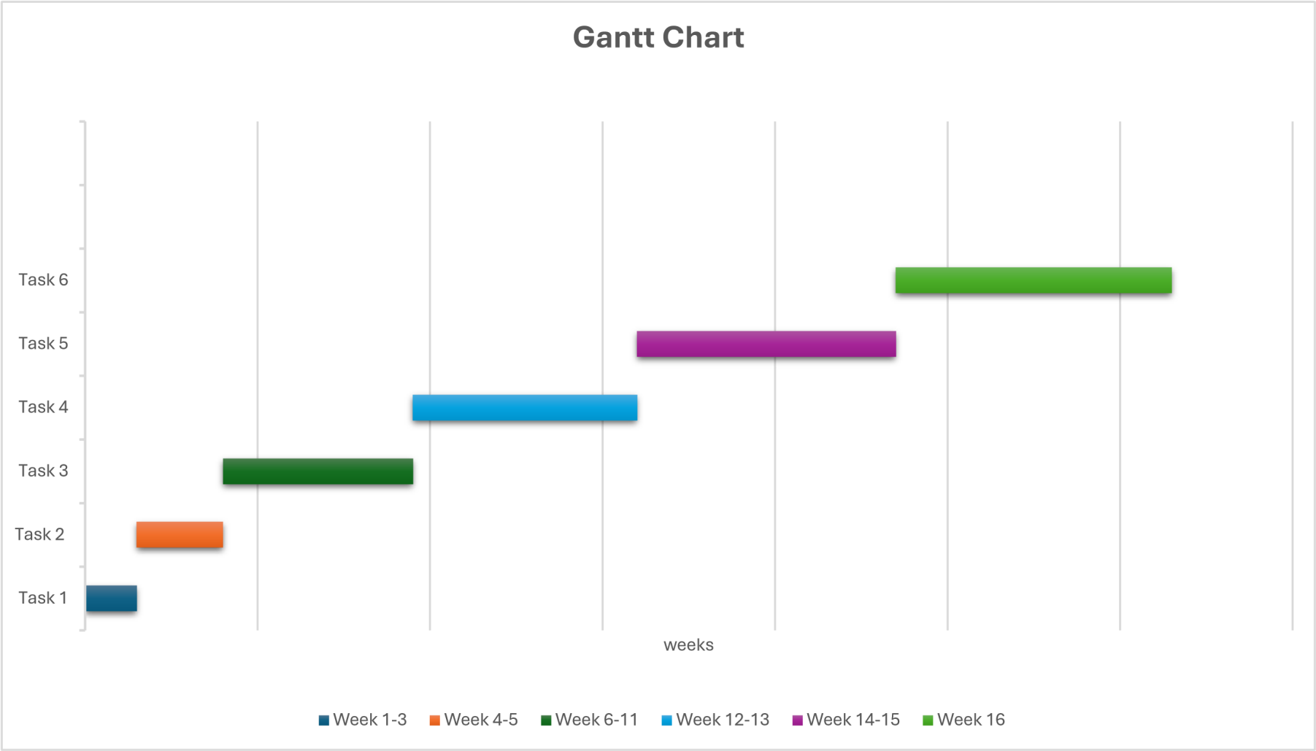
1.8.2 GANTT CHART

CHAPTER 2: FIRST REVIEW

2.1 Literature Review
The management of industrial attachment programs represents a critical intersection of educational administration, student development, and industry-academia collaboration. This literature review examines existing research on industrial attachment management systems, digital learning platforms, stakeholder coordination, and the technological frameworks that support these critical educational initiatives.

2.1.1 The Importance of Industrial Attachment Programs
Attachment programs create a platform for students to assimilate theory into practice. Industrial attachment programs serve as essential bridges between theoretical academic knowledge and practical workplace competencies. Adamu et al (2017), identified that industrial attachment enables students to acquire essential employability skills including teamwork, problem-solving, communication skill, and critical thinking qualities that are increasingly valued by employers in today's competitive job market. Davies (1990) traces the historical origins of industrial attachment to the Second World War period, noting that these programs emerged to address the growing gap between industry skill demands and traditional undergraduate curriculum content in response to rapid technological advances. This historical perspective underscores the enduring relevance of attachment programs in preparing students for evolving workplace requirements.
Leslie (1991) identifies multiple stakeholder benefits from industrial attachment programs, demonstrating that employers view these programs as mechanisms for bridging the theory-practice divide, while academics recognize their value in helping students clarify career objectives and enhance employment prospects. Furthermore, Leslie outlines broader benefits including expanded student knowledge through increased awareness of available opportunities, exposure to industry diversity, and significant personal development outcomes. Industrial attachments enables students to become self-starters by going through the working environment thereby raising employment opportunities for themselves in the current dwindling employment opportunities where employers have raised a stake by looking for highly competent performers.
King (1994) emphasizes the development of critical soft skills including self-confidence, time management, and verbal and written communication abilities through industrial attachment experiences. Hughes and Moore (1999) support this view, noting that attachment experiences enhance theoretical training while simultaneously building practical competencies.

2.1.2 Challenges in Traditional Attachment Management
Despite their recognized importance, industrial attachment programs face significant administrative challenges when managed through traditional manual systems. Sulaiman et al. (2022) observe that as student enrollment in industrial training increases semester by semester, the volume of data requiring collection, storage, and retrieval grows correspondingly, making manual processes increasingly tedious and time-consuming. This scalability challenge represents a fundamental limitation of paper-based management approaches.
Falebita (2022) further elaborates on the problems associated with paper-based information systems, noting that managing information through manual approaches requires physical exertion to retrieve, alter, and re-file paper records, resulting in data inconsistency and redundancy. The administrative burden extends beyond simple data volume concerns, creating fragmented information flows, limited visibility into student progress, and difficulties in coordinating multiple stakeholders across institutional and organizational boundaries.
Bharamagoudar et al. (2013) emphasize that the creation and management of accurate, up-to-date information regarding students' academic careers is critically important in universities and colleges, yet traditional systems often fail to maintain this standard. These operational inefficiencies compromise program quality and reduce the ability of educational institutions to demonstrate program outcomes to accreditation bodies and external stakeholders.

2.1.3 Existing Digital Solutions for Attachment Management
Recognizing these challenges, researchers and institutions have developed various technology-enabled solutions to industrial attachment management. Several institutions have successfully implemented web-based internship management systems that demonstrate the feasibility and benefits of digital approaches.
The iMAPS system developed at Universiti Teknologi MARA (UiTM) represents a pioneering effort in computerizing practical training processes (IEEE, 2017). This web-based system enables internship eligibility checking, registration, visit scheduling, and monitoring of industrial internship programs, providing students with the ability to check application status online rather than physically visiting coordinator offices. The system also includes online assessment functionality for industrial supervisors to evaluate trainees, streamlining the evaluation process.
Xue (2015) developed a university students' internship employment tracking system based on the MVC Framework, demonstrating the applicability of modern software architecture patterns to industrial attachment management. These existing systems provide valuable precedents for the proposed Industrial Attachment Management System, validating the technical feasibility and organizational value of integrated digital platforms.

2.1.4 Web-Based Student Information Management Systems
The proposed system aligns with broader developments in web-based student information management systems (SIMS). Bharamagoudar et al. (2013) explain that student information systems deal with all kinds of student details, academic related reports, course details, curriculum, and placement details, tracking all details of a student from day one to the end of the course for reporting purposes, attendance tracking, and progress monitoring.
Hu (2016) argues that development of web-based student information management systems represents an inevitable trend in campus information technology and an important means of institutional advancement. Research demonstrates that adopting traditional student information management modes, such as direct manual management or systems with low openness, inevitably wastes significant human, material, and financial resources. Building network management platforms based on Web technology has become an important task and development direction for teaching management in most colleges and universities.
The Online Student Information System (OSIS) at Mzuzu University demonstrates the practical benefits of centralized web-based management (Chawinga et al 2018). The study found that key benefits to students include 24/7 web-based access to information about class and examination timetables, school events, and holidays. The system also allows users to publish articles to share experience, knowledge, and views, and participate in discussion forums, creating a more collaborative educational environment.

2.1.5 Information Systems and Organizational Performance
The theoretical foundation for implementing attachment management systems draws from broader information systems research. Hasan (2018) demonstrates that information systems management plays a significant role in contributing to organizational performance through structured procedures and functions. This perspective positions the proposed Industrial Attachment Management System not merely as a technological tool but as a strategic organizational asset capable of enhancing institutional effectiveness.
Falebita (2022) emphasizes that the reliability and success of any organization, such as an academic institution, relies on its ability to provide secure, accurate, and timely data about its operations. Effective record management represents a critical component of organizational success in educational contexts. Kemoni and Wamukoya (2000) argue that effective record-management systems assist organizations, including universities, in managing large data volumes while ensuring record reliability within appropriate frameworks. This observation underscores the importance of systematic data management capabilities in the proposed system, particularly given the multi-year documentation requirements typical of industrial attachment programs.

2.1.6 Stakeholder Coordination in Experiential Learning
Industrial attachment programs inherently involve complex stakeholder coordination challenges. Students, institutional supervisors, company supervisors, and administrative personnel must collaborate across organizational boundaries throughout the attachment lifecycle. Traditional communication methods including phone calls, emails, and physical meetings—often prove inadequate for maintaining consistent information flow and ensuring accountability.
Gilbert (2007) emphasizes that addressing learner needs directly impacts academic performance outcomes. In the context of industrial attachments, this principle suggests that systems facilitating clear communication, timely feedback, and accessible resources could significantly enhance student learning experiences and attachment outcomes.
Kukreti and Dani (2020) explicitly recommend that "an online platform for the industrial training students must be prepared where they can share their learning along with problems associated with various tasks of industrial training." This recommendation highlights the need for integrated digital platforms that facilitate communication, documentation, and progress tracking throughout the attachment lifecycle. The proposed system's role-based interfaces and automated notification mechanisms directly address these coordination requirements.

2.1.7 Role-Based Access Control in Educational Systems
A critical technical consideration for the proposed system involves implementing appropriate security and access control mechanisms. Role-Based Access Control (RBAC) has emerged as the standard approach for managing permissions in educational information systems.
Research by Lei et al. (2017) demonstrates that access control constitutes the core of data security for any implemented system, with RBAC offering an effective approach to enhance system security and improve user role and system privilege management. In educational administration systems, RBAC provides a security management model of "user classification, role authorization, and unified management" that is particularly suited to multi-level applications by controlling the data range accessible to users (Ruan and Shahrestani, 2010).
The application of RBAC in educational contexts offers several advantages. Permissions are associated with roles rather than individual users, and appropriate roles are assigned to users based on their functions within the system. This approach proves particularly valuable in educational settings with large numbers of users with overlapping requirements and numerous objects requiring access control. Educational institutions commonly implement roles such as Student, Teacher, Administrator, and Registrar, with each role having carefully defined permissions appropriate to their responsibilities.
Ferraiolo et al. (1995) established that role-based protection enforces the principle of least privilege, minimizing risks of unauthorized access and reducing potential security vulnerabilities. For the proposed Industrial Attachment Management System, RBAC enables distinct access levels for students, institutional supervisors, company supervisors, and administrators, ensuring that each stakeholder accesses only information relevant to their specific responsibilities.

2.1.8 Digital Logbooks and Progress Monitoring
The transition from paper-based to electronic logbooks represents a significant advancement in attachment documentation. Digital logbooks offer several advantages over traditional paper formats, including reduced risk of loss or damage, improved accessibility for supervisors, facilitated real-time progress monitoring, and enhanced data analysis capabilities for program evaluation.
Research on digital learning portfolios suggests that structured, technology-enabled documentation tools can promote reflective learning practices while simultaneously generating valuable assessment data. The proposed system's electronic logbook functionality incorporates these principles, requiring weekly student submissions and providing supervisors with continuous visibility into student activities and learning progression.

2.1.9 Data Analytics for Program Improvement
Modern educational management increasingly relies on data-driven decision making for program improvement and quality assurance. The proposed system's analytics capabilities including geographical distribution tracking and skills exposure monitoring align with contemporary expectations for evidence-based program management.
Analytics dashboards provide administrators with real-time insights into placement patterns, industry engagement, and student performance distributions. This data infrastructure supports continuous program improvement efforts while facilitating responses to accreditation requirements and stakeholder accountability expectations. The ability to generate comprehensive reports on supervisor assessments, visit compliance, and placement outcomes represents a significant advancement over manual data compilation approaches.

2.1.10 Technology Adoption and User Acceptance
The transition from manual to digital systems aligns with broader trends in educational technology adoption. Modern learners require engaging, technology-mediated experiences, suggesting that digital platforms for attachment management could enhance student engagement while simultaneously improving administrative efficiency. However, successful implementation requires careful attention to user needs, system usability, and integration with existing institutional processes.
Research on student information systems at Mzuzu University found that while students appreciated the benefits of online systems, challenges such as server congestion during peak registration periods and insufficient ICT infrastructure could impede effective adoption (Chawinga and Zinn, 2018). These findings underscore the importance of adequate technical infrastructure and thoughtful implementation strategies for web-based educational management systems.

2.1.11 Security and Privacy Considerations
As educational institutions increasingly adopt digital management systems, data security and student privacy considerations become paramount. Falebita (2022) notes that many institutions have migrated to web-based student information management systems without adequately considering the security architecture of their web portals. The proposed system must implement appropriate authentication mechanisms, role-based access controls, and data protection measures to safeguard sensitive student information, academic records, and institutional data.
Best practices in educational technology emphasize the importance of transparent data handling policies, user consent mechanisms, and compliance with relevant privacy regulations. The system's role-based architecture, which provides stakeholders with access only to information relevant to their specific responsibilities, represents one approach to balancing functionality with privacy protection. Implementation of industry-standard encryption for passwords and secure HTTPS communication protocols further strengthens system security.

2.1.12 Summary
The reviewed literature demonstrates clear needs for integrated digital solutions to industrial attachment management challenges. While traditional manual systems have served educational institutions for decades, they increasingly prove inadequate for managing growing student populations, coordinating multiple stakeholders, and meeting contemporary expectations for data-driven program management.
Existing research and implemented systems from institutions such as Universiti Teknologi MARA, universities in Sri Lanka, and various African institutions validate the technical feasibility and organizational value of web-based attachment management platforms. These precedents demonstrate that digital systems can successfully address coordination challenges, improve documentation practices, enhance communication between stakeholders, and provide valuable analytics for program improvement.
The proposed Industrial Attachment Management System builds upon these foundations, addressing documented needs through role-based functionality grounded in RBAC principles, automated coordination mechanisms, digital documentation tools, and analytics capabilities that collectively promise to enhance attachment program effectiveness and student learning outcomes. The integration of established security practices, user-centered design principles, and proven web technologies positions the system to deliver meaningful improvements over existing manual processes.

2.2 Research Methodology
This section outlines the research approach and development methodology employed in designing and implementing the Industrial Attachment Management System.

2.2.1 Research Approach
This project adopts a Design Science Research approach, which focuses on creating and evaluating innovative artifacts designed to solve identified organizational problems. The research process follows an iterative cycle of problem identification, solution design, artifact development, and evaluation, ensuring that the final system effectively addresses the documented challenges in industrial attachment management.

2.2.2 Development Methodology: Agile Scrum Framework
The system development will employ the Agile Scrum methodology, which is particularly well-suited for web-based application development within constrained academic timeframes. The Scrum framework provides several advantages for this project:

Iterative Development: The 16-week project timeline is divided into four-week sprints, each delivering functional system components that can be tested and refined based on stakeholder feedback.
Flexibility and Adaptability: Agile methodologies accommodate evolving requirements and priority adjustments as development progresses and user needs become clearer through testing and feedback.
Incremental Delivery: Core functionality is developed first, with additional features added in subsequent sprints, ensuring that essential system components are completed even if time constraints limit advanced feature implementation.
Continuous Stakeholder Engagement: Regular sprint reviews and demonstrations maintain alignment between system functionality and stakeholder needs throughout the development process.

2.2.3 Sprint Structure
Sprint 1 (Weeks 1-4):
Requirements gathering, system architecture design, database schema design, development environment setup, and basic authentication module development.
Sprint 2 (Weeks 5-8):
Student portal development including registration, assumptions module, and electronic logbook functionality; initial testing with sample data.
Sprint 3 (Weeks 9-12):
Supervisor dashboard development (both institutional and company), visit scheduling module, grading functionality, and notification system implementation.
Sprint 4 (Weeks 13-16):
Administrator dashboard development, analytics implementation, system integration, comprehensive testing, documentation, and final presentation preparation.
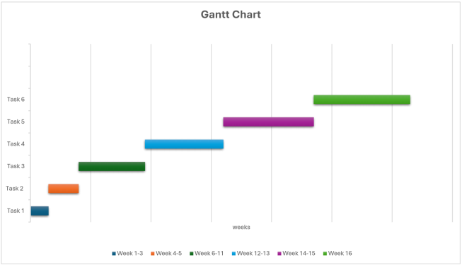

2.2.4 Data Gathering Methods
I will implement multiple data gathering techniques to ensure comprehensive requirements understanding and system validation:
Interviews: Semi-structured interviews will be conducted with 5-10 participants including students who have completed industrial attachments, institutional supervisors, and administrative staff. Interview questions will focus on current process challenges, information needs, and desired system functionality. Interview sessions will last approximately 30-45 minutes and will be documented through written notes with participant consent.
Questionnaires: Online questionnaires will be distributed to a broader sample of students and supervisors to gather quantitative data on current system pain points, feature priorities, and technology adoption readiness. Questionnaires will use a combination of Likert-scale questions and open-ended responses to capture both measurable preferences and detailed feedback.
Document Analysis: Existing attachment documentation including student logbooks, assessment forms, placement agreements, and administrative reports will be analyzed to understand current data structures, workflows, and information requirements. This analysis will inform database design and system functionality specifications.
Observation: Informal observation of current attachment management processes will be conducted to identify workflow bottlenecks, communication patterns, and documentation practices that may not be explicitly articulated during interviews. Observation will occur in administrative offices (with permission) and through review of email communications and scheduling processes.
Prototyping and User Testing: Interactive prototypes will be developed at key project milestones and tested with volunteer participants (3-5 users per testing session). Users will be asked to complete specific tasks while thinking aloud, with observations recorded regarding usability issues, navigation challenges, and feature comprehension. Feedback from testing sessions will directly inform subsequent development iterations.

2.2.5 System Testing Strategy
The testing strategy encompasses multiple levels:
Unit Testing:
Individual components and functions will be tested in isolation to ensure correct behavior.
Integration Testing:
Module interactions will be tested to verify proper data flow and communication between system components.
User Acceptance Testing:
Representative users from each stakeholder group will test the system with realistic scenarios to validate that functionality meets requirements.
Performance Testing:
The system will be tested under simulated load conditions to ensure acceptable response times with multiple concurrent users.

2.3 Resource Requirements
This section identifies the hardware, software, and tools required for successful project implementation, with justifications for each resource.

2.3.1 Hardware Requirements
Development Computer:
- Specification: Laptop with minimum Intel Core i5 processor, 8GB RAM, 256GB storage
- Required for running development environment, database server, and testing multiple system components simultaneously. Already owned by the student.
Testing Devices:
- Specification: Additional laptop/desktop, smartphone, and tablet devices for cross-platform testing
- Essential for verifying responsive design functionality and ensuring consistent user experience across different devices and screen sizes. Devices will be borrowed from fellow students and family members.

2.3.2 Software Requirements
Frontend Development Framework:
- Tool: React with TypeScript
- Version: React 18.x, TypeScript 5.x
- React provides component-based architecture enabling reusable UI elements and efficient rendering. TypeScript adds static typing, reducing runtime errors and improving code maintainability. The combination supports development of responsive, user-friendly interfaces required for role-based dashboards.
Backend Development Framework:
- Tool: Java Spring Boot
- Version: Spring Boot 3.x
- Spring Boot provides comprehensive framework for building enterprise-grade web applications with built-in security, database integration, and RESTful API development capabilities. Java's platform independence and robust ecosystem support scalable, maintainable backend development.
Integrated Development Environment:
- Tool: IntelliJ IDEA Community Edition
- Version: 2024.x
- IntelliJ IDEA offers advanced code completion, debugging, and refactoring tools specifically optimized for Java and Spring Boot development. The Community Edition provides all essential features at no cost, making it ideal for student projects.
Database Management System:
- Tool: H2 Database (development), MySQL (production)
- Version: H2 2.x, MySQL 8.x
- H2 provides lightweight in-memory database perfect for development and testing with zero configuration overhead. MySQL offers robust, industry-standard relational database management for production deployment, supporting complex queries and data relationships required for attachment management.
Web Server:
- Tool: Embedded Apache Tomcat
- Version: Tomcat 10.x (embedded with Spring Boot)
- Embedded Tomcat eliminates separate server configuration requirements, simplifying deployment and development workflow. Spring Boot's embedded server approach enables running the complete application as standalone executable.
Version Control System:
- Tool: Git with GitHub
- Version: Git 2.x, GitHub free student account
- Git provides distributed version control enabling code backup, change tracking, and collaboration capabilities. GitHub offers free private repositories for students, facilitating code management and providing portfolio demonstration for future employment opportunities.
API Testing Tool:
- Tool: Postman
- Version: Latest free version
- Postman enables systematic testing of RESTful API endpoints during backend development, ensuring proper request/response handling before frontend integration. Essential for debugging and validating server-side functionality.
Database Design Tool:
- Tool: MySQL Workbench
- Version: 8.x
- Provides visual database design capabilities, enabling creation of entity-relationship diagrams and automated generation of database schemas. Facilitates proper database structure planning before implementation.
Diagramming Tool:
- Tool: Draw.io (diagrams.net)
- Version: Web-based, latest version
- Required for creating use case diagrams, activity diagrams, and system architecture diagrams for project documentation. Web-based tools eliminate installation requirements and enable easy diagram sharing with supervisors.

2.3.3 Hosting and Deployment Resources
Web Hosting Service:
- Service: Shared hosting plan (e.g., HostGator, Bluehost, or similar)
- Duration: 4 months
- Cost: $40
- Required for deploying the functional system for demonstration and testing purposes. Shared hosting provides adequate resources for prototype deployment with moderate user loads at student-friendly pricing.
Domain Name:
- Service: Domain registration (. co.zw)
- Duration: 1 year
- Cost: $10
- Professional domain name enhances project credibility and provides accessible URL for stakeholder testing and demonstration during project evaluation.

2.3.4 Communication and Documentation Tools
Internet Connectivity:
- Resource: Mobile data bundles and Wi-Fi access
- Estimated Cost: $30 for 4 months
- Essential for online research, accessing cloud-based development resources, version control system synchronization, and communication with project supervisor and testing participants.
Documentation Software:
- Tool: Microsoft Word or Google Docs
- Required for writing project reports, user manuals, and technical documentation. Google Docs provides real-time collaboration with supervisors and automatic cloud backup.

2.4 Functional Requirements
This section specifies the functional capabilities that the Industrial Attachment Management System must provide to meet stakeholder needs. Requirements are organized by user role.

2.4.1 Student Portal Functional Requirements
FR1: The system shall allow students to register and login using their institutional registration numbers and secure passwords.
FR2: The system shall provide students with a comprehensive dashboard displaying all available submenus and attachment-related information.
FR3: The system shall provide an instructions page clearly explaining all system processes and requirements.
FR4: The system shall enable students to register their attachment type, selecting between institutional attachments or external industry placements.
FR5: The system shall allow students to submit personal details and company information through the Student Assumptions module.
FR6: The system shall enable students to upload attachment contracts and onboarding orientation forms in PDF or word formats.
FR7: The system shall provide an electronic logbook interface where students can record daily tasks and activities.
FR8: The system shall require students to submit logbook entries on a weekly basis.
FR9: The system shall allow students to upload final attachment reports in multiple formats (PDF, DOCX).
FR10: The system shall enable students to view visit schedules proposed by institutional supervisors.
FR11: The system shall allow students to approve or request rescheduling of supervisor visits.
FR12: The system shall display notifications regarding pending submissions, scheduled visits, and assessment updates.

2.4.2 Company Supervisor Functional Requirements
FR13: The system shall provide company supervisors with secure login credentials via email from institutional supervisors.
FR14: The system shall allow company supervisors to submit comprehensive marks and assessment remarks covering the entire attachment period for every student.

2.4.3 Institutional Supervisor Functional Requirements
FR15: The system shall provide institutional supervisors with dashboards displaying all assigned students.
FR16: The system shall allow supervisors to view detailed student assumptions including company information and attachment duration.
FR17: The system shall enable supervisors to access student contracts and onboarding orientation documents.
FR18: The system shall allow supervisors to view student logbook entries and track progress throughout the attachment period.
FR19: The system shall provide a visit scheduling module where supervisors can select preferred dates and times for site visits.
FR20: The system shall automatically generate notifications to students when visits are scheduled.
FR21: The system shall allow supervisors to submit separate marks for each of the two mandatory site visits.
FR22: The system shall enable supervisors to provide assessment comments and feedback for each visit.
FR23: The system shall allow supervisors to view company supervisor assessments for their assigned students.

2.4.4 Administrator Functional Requirements
FR24: The system shall provide administrators with a centralized dashboard displaying all registered students across the institution.
FR25: The system shall generate analytics charts showing geographical distribution of student placements.
FR26: The system shall provide analytics on skills exposure across different industries and companies.
FR27: The system shall allow administrators to view all student assumptions and attachment details.
FR28: The system shall enable administrators to manage lecturer profiles including adding, editing, and deactivating accounts.
FR29: The system shall allow administrators to assign institutional supervisors to students based on expertise and workload.
FR30: The system shall provide administrators with access to both company supervisor scores and institutional supervisor scores for all students.
FR31: The system shall enable administrators to monitor visit scheduling patterns and compliance rates.
FR32: The system shall allow administrators to generate comprehensive reports on attachment program statistics.
FR33: The system shall provide administrators with export functionality for data analysis and institutional reporting.

2.4.5 Communication and Notification Functional Requirements
FR34: The system shall send automated email notifications when institutional supervisors schedule visits.
FR35: The system shall generate in-system notifications visible on user dashboards.
FR36: The system shall send reminder notifications for pending visit approvals.
FR37: The system shall notify students of approaching logbook submission deadlines.
FR38: The system shall maintain comprehensive records of all notification history for audit purposes.

2.5 Non-Functional Requirements
Non-functional requirements specify the quality attributes and constraints that the system must satisfy to provide acceptable user experience and operational reliability.
NFR1: Performance Requirements
Requirement: The system shall provide responsive performance to ensure efficient user interaction.
Fit Criterion: 95% of page loads shall complete within 3-5 seconds under normal operating conditions with up to 50 concurrent users.
Requirement: Database queries shall execute efficiently to minimize wait times.
Fit Criterion: Complex queries (such as generating analytics dashboards) shall return results within 5 seconds.
NFR2: Usability Requirements
Requirement: The system interface shall be intuitive and easy to navigate for users with basic computer literacy.
Fit Criterion: 90% of new users shall successfully complete basic tasks (login, navigate to logbook, submit entry) without external assistance after reviewing the instructions page.
Requirement: The system shall provide clear error messages and guidance when users encounter problems.
Fit Criterion: All error messages shall include specific descriptions of the problem and suggested corrective actions.
NFR3: Security Requirements
Requirement: The system shall protect user credentials and sensitive data from unauthorized access.
Fit Criterion: All passwords shall be encrypted using industry-standard hashing algorithms (BCrypt or similar) before database storage.
Requirement: The system shall implement role-based access control to ensure users access only information relevant to their roles.
Fit Criterion: 100% of data access requests shall be validated against user role permissions, with unauthorized attempts logged and blocked.
Requirement: The system shall maintain secure communication between client and server.
Fit Criterion: All data transmission shall occur over HTTPS protocol when deployed to production environment.
NFR4: Reliability Requirements
Requirement: The system shall be available for use during standard academic and business hours.
Fit Criterion: System uptime shall be at least 95% during weekdays between 8:00 AM and 6:00 PM.
Requirement: The system shall preserve user data integrity during transactions.
Fit Criterion: 100% of completed submission transactions (logbook entries, reports, assessments) shall be successfully saved to the database or display error notification if saving fails.
NFR5: Compatibility Requirements
Requirement: The system shall function correctly across multiple web browsers.
Fit Criterion: Full functionality shall be available on the latest versions of Chrome, Firefox, Safari, and Edge browsers.
Requirement: The system shall provide responsive design supporting various device types.
Fit Criterion: All functionality shall be accessible and properly displayed on desktop computers, tablets, and smartphones with screen sizes ranging from 5 inches to 27 inches.
NFR6: Maintainability Requirements
Requirement: The system codebase shall follow established coding standards to facilitate future maintenance.
Fit Criterion: All code modules shall include inline comments explaining complex logic, and the project shall include comprehensive technical documentation for future developers.
Requirement: The system architecture shall support modular updates without requiring complete system redeployment.
Fit Criterion: Individual features or modules shall be updatable independently without affecting unrelated system functionality.
NFR7: Scalability Requirements
Requirement: The system architecture shall accommodate future growth in user numbers and data volume.
Fit Criterion: The database design and server architecture shall support expansion to at least 500 concurrent users and 10,000 student records without requiring fundamental restructuring.

2.6 Modelling Diagrams
This section presents visual models representing system functionality and user interactions. These diagrams provide clear representations of system requirements and operational workflows.

2.6.1 Use Case Diagram
The Use Case diagram illustrates the interactions between different system actors (Students, Institutional Supervisors, Company Supervisors, and Administrators) and the system functionalities available to each role.

2.6.1.1 Primary Actors:
- Student
- Institutional Supervisor
- Company Supervisor
- Administrator

2.6.1.1.1 Student Use Cases:

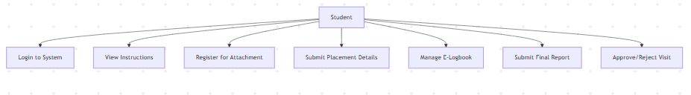

2.6.1.1.2 Institutional Supervisor Use Cases:
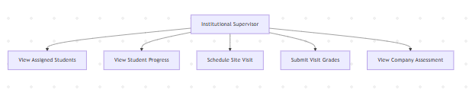

2.6.1.1.3 Company Supervisor Use Cases:

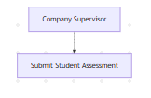

2.6.1.1.4 Administrator Use Cases:

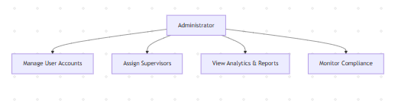

2.6.2 Overall Use case for the whole System
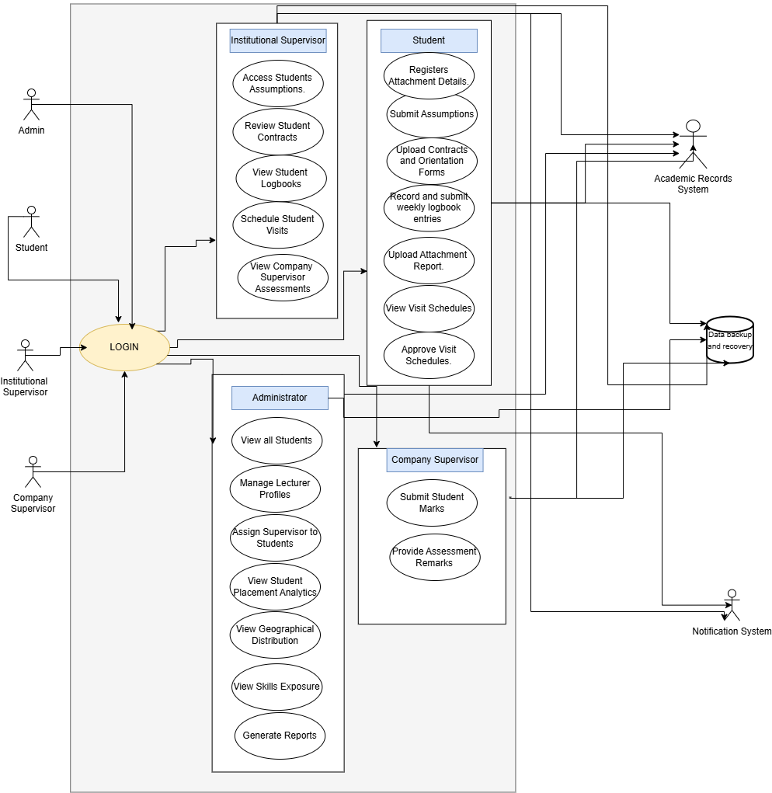

2.6.2 Activity Diagram - Visit Scheduling Process
The Activity diagram illustrates the workflow for the visit scheduling process, which involves coordination between institutional supervisors and students.
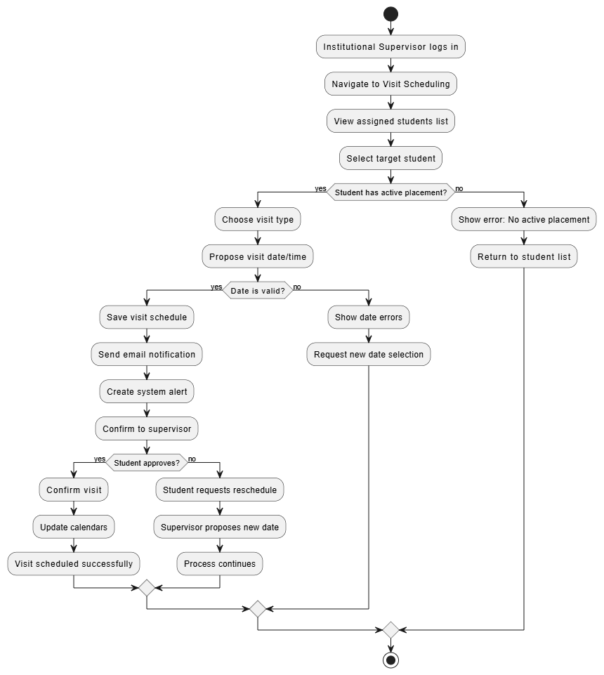

2.6.3 Entity-Relationship Diagram
Entity-Relationship (ER) diagram would help me to provide valuable documentation of the database structure:

Core Entities:
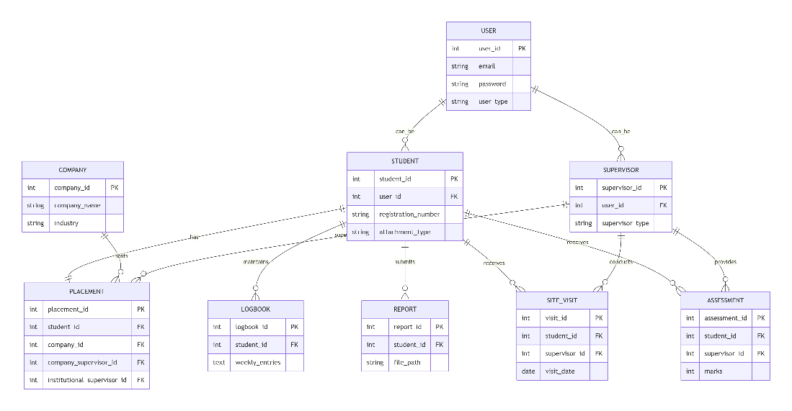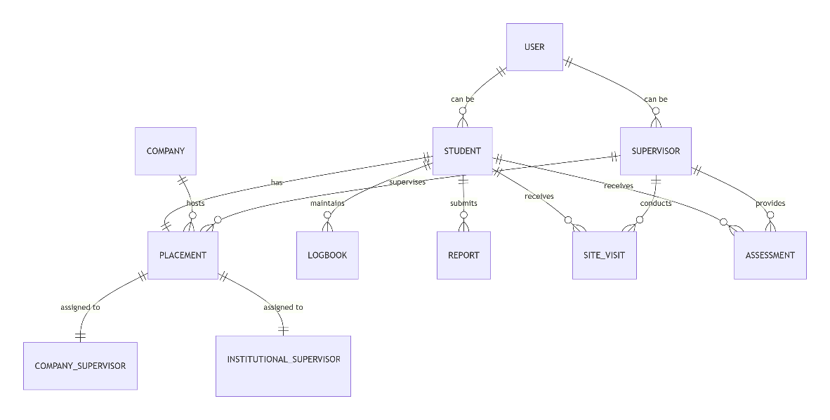

CHAPTER 3: SECOND REVIEW

3.1 Class Diagram for Industrial Attachment Management System
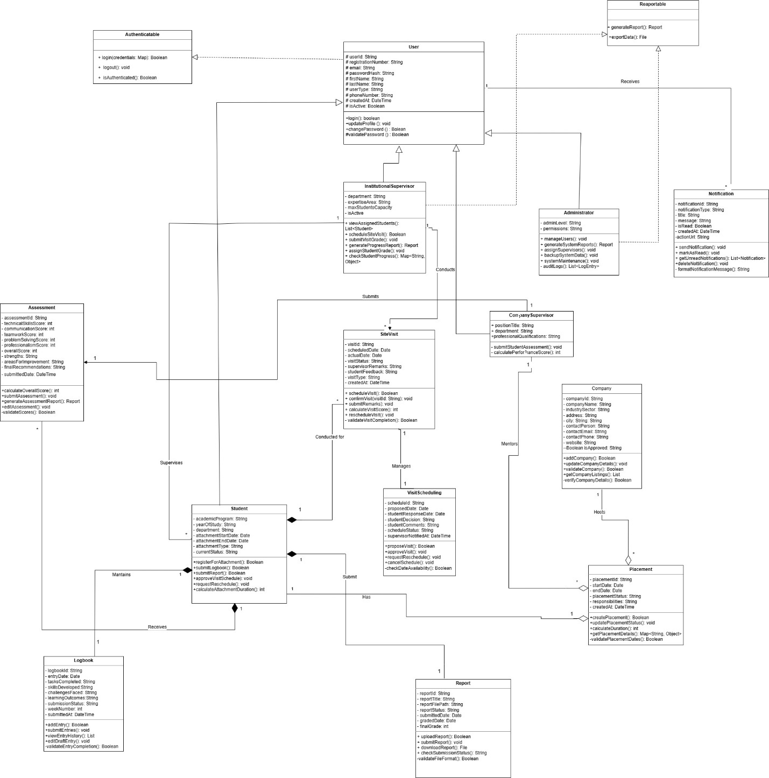

3.1.1 Class Diagram Explanation
Foundation for database design and object-oriented development, ensuring consistent data relationships and system integrity.
Static Structure: Shows system components, their attributes, methods, and relationships at rest.

3.1.1.1 Core Components:
- User Hierarchy: Base class with Student, Supervisor, Administrator specializations
- Placement Hub: Central entity connecting Student + Company + both Supervisors
- Document System: Logbook, Report, Assessment for progress tracking
- Operations: SiteVisit and Notification for scheduling and alerts

3.1.1.2 Key Relationships:
- Inheritance: User roles share common properties
- Composition: Student exclusively owns work products
- Realization: Standardized interfaces for authentication and reporting

3.2 Object Diagram
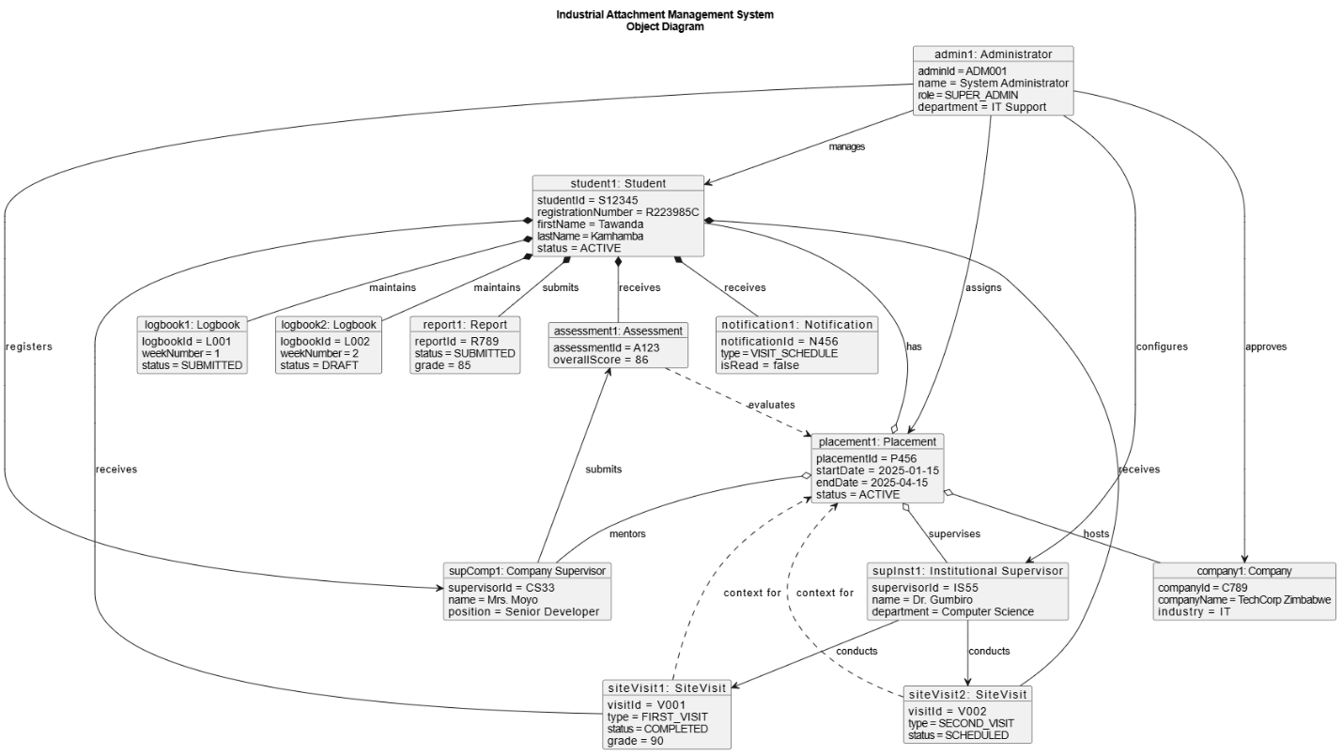

3.2.1 Object Diagram Explanation
Provides concrete example of how all system components interconnect in a real scenario, showing actual data values and relationship types
Purpose: Shows a snapshot of system objects and their relationships at a specific moment

3.2.1.1 Current Instance:
- Student Tawanda Kamhamba (R223985C) with active placement at TechCorp Zimbabwe
- Two supervisors assigned: Dr. Gumbiro (Institutional) and Mrs. Moyo (Company)
- Ongoing attachment from Jan 15 - Apr 15, 2025

3.2.1.2 Key Relationships:
- Composition: Student exclusively owns logbooks, reports, assessments, and visits
- Aggregation: Placement contains student, company, and supervisors (shared ownership)
- Association: Supervisors conduct visits and submit assessments
- Dependency: Visits and assessments rely on placement context

3.2.1.3 Current Status:
- First visit completed (90/100), second visit scheduled
- Week 1 logbook submitted, week 2 in draft
- Final report submitted (85/100), company assessment provided (86/100)
- Unread notification about scheduled visit
This sequence diagram illustrates the scenario of an Institutional Supervisor scheduling a site visit.

3.3 Sequence Diagram: Site Visit Scheduling
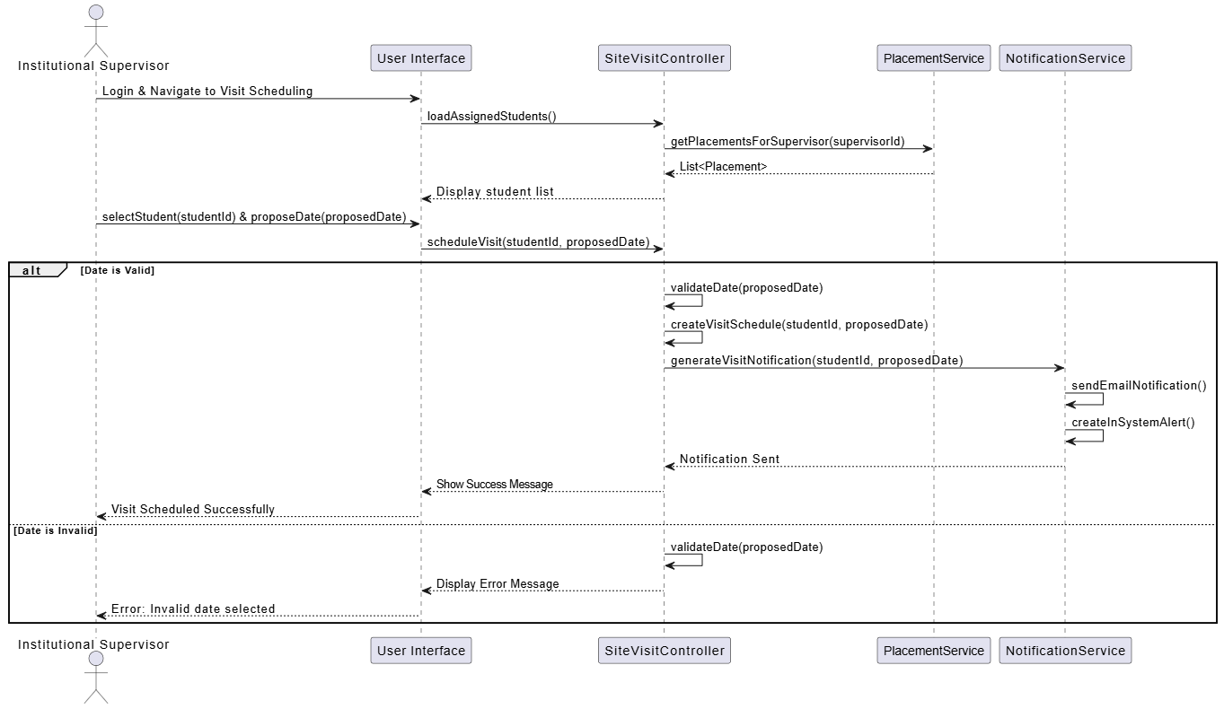

3.3.1 Sequence Diagram: Site Visit Scheduling(Explanation)
Provides clear visualization of the complete scheduling workflow with error handling, showing how components collaborate in real-time. Sequence Diagram Notes: Site Visit Scheduling
Purpose: Shows step-by-step interaction flow for scheduling supervisor site visits

3.3.1.1 Key Flow:
- Initialization: Supervisor logs in and loads assigned students
- Scheduling: Selects student and proposes visit date
- Validation: System checks date availability and business rules
- Processing: Creates schedule and notifies student via email + system alert
- Confirmation: Success/error message returned to supervisor

3.3.1.2 Critical Components:
- Institutional Supervisor: Initiates and controls the process
- SiteVisitController: Orchestrates the entire workflow
- PlacementService: Manages student placement data
- NotificationService: Handles all student communications

3.3.1.3 Key Features:
- Alternative Paths: Separate flows for valid/invalid dates
- Synchronous Flow: Sequential execution ensures data consistency
- Self-Calls: Internal validation and processing within controller
- Clear Sections: Divided into initialization and scheduling phases

3.4 Communication Diagram
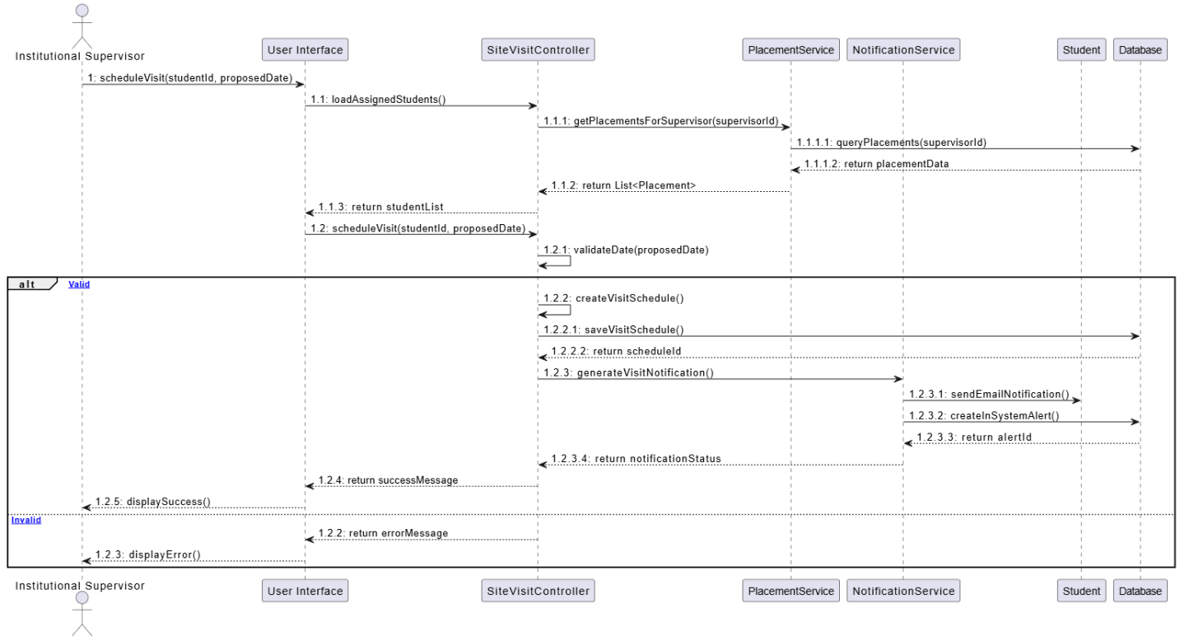
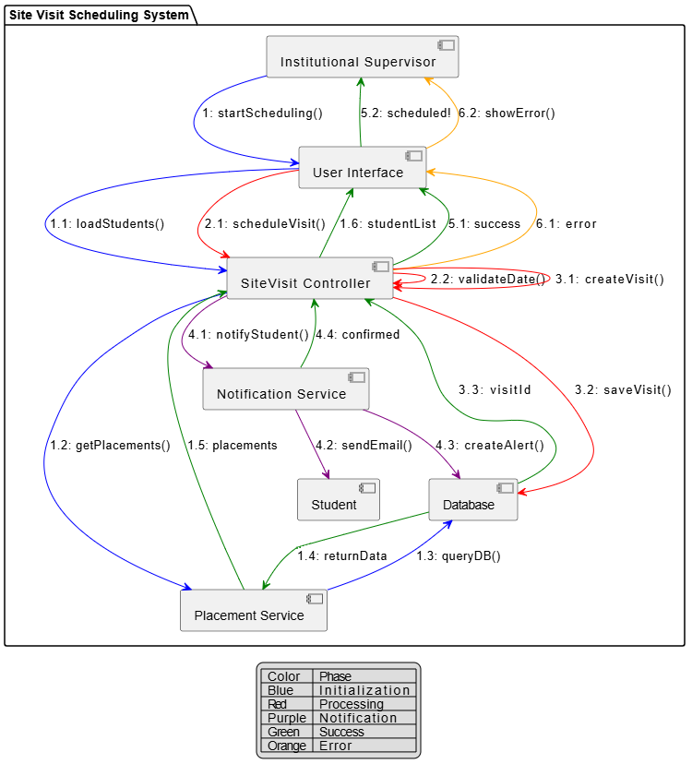

3.4.1 Communication Diagram Explanation
- Illustrates the message flow for scheduling industrial attachment site visits
- Shows how institutional supervisors coordinate with students through the system

3.4.1.1 Key Components:
- Institutional Supervisor: Initiates the visit scheduling process
- SiteVisit Controller: Orchestrates the entire scheduling workflow
- Placement Service: Manages student-company assignment data
- Notification Service: Handles all communication with students
- Database: Stores and retrieves all persistent system data

3.4.1.2 Message Flow:
- Initialization: Supervisor accesses system and loads assigned students
- Validation: System checks date availability and conflicts
- Processing: Visit schedule created and saved to database
- Notification: Student receives email and system alert
- Confirmation: Supervisor receives success/error feedback

3.4.1.3 System Collaboration:
- Objects work together through sequential message passing
- Hierarchical numbering (1.2.3) shows nested operations
- Synchronous communication ensures data consistency
- Error handling provides user feedback for invalid inputs

3.5 State Diagram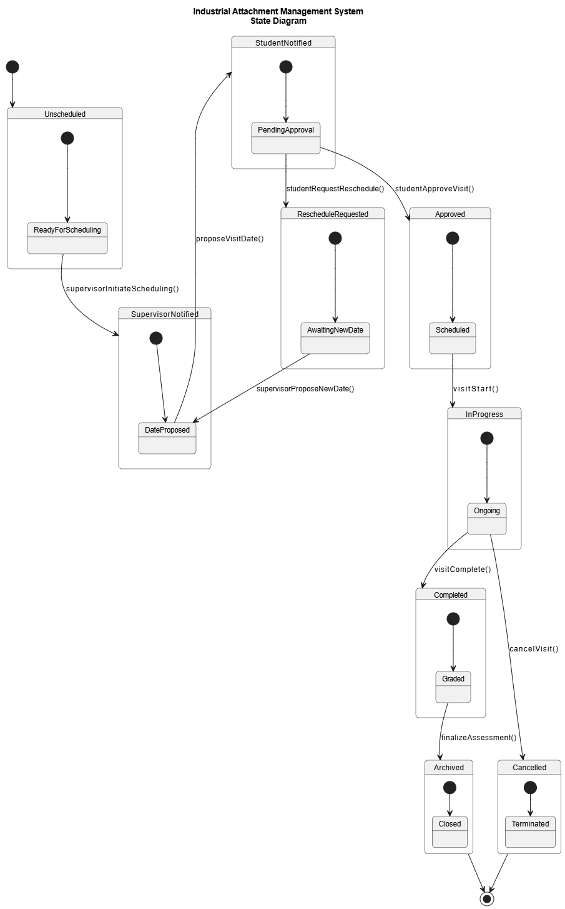

3.5.1 State Diagram: Site Visit Lifecycle (Explanation)
Provides clear visualization of the visit scheduling workflow and all possible state changes for better system understanding and debugging.

3.5.1.1 Purpose:
- Models the complete lifecycle of a site visit from initiation to completion
- Shows all possible states and transitions during visit scheduling process

3.5.1.2 Key States:
- Unscheduled → Proposed → Pending Approval: Initial scheduling phase
- Approved → Scheduled → In Progress: Active visit execution
- Completed → Graded → Archived: Post-visit assessment and closure
- Reschedule Requested: Handles date change requests from students

3.5.1.3 Critical Transitions:
- Supervisor initiates scheduling and proposes dates
- Student approves or requests rescheduling
- Visit progresses from scheduled to in-progress to completed
- Final assessment moves visit to graded and archived states

3.6 Process Design
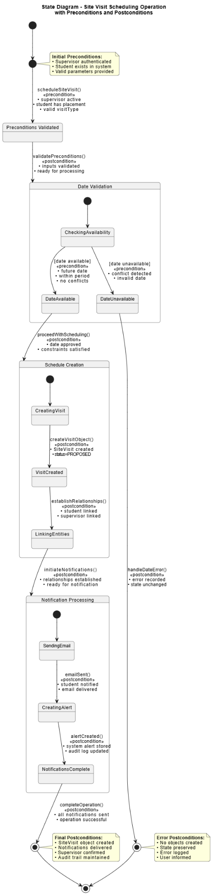

3.6.1 State Diagram showing Precondition and Postconditions: Site Visit Scheduling Operation
Models the complete workflow of site visit scheduling with explicit preconditions and postconditions

3.6.1.1 Key States:
- Preconditions Validated: All input requirements verified before processing
- Date Validation: Business rules checked (availability, conflicts, period)
- Schedule Creation: Visit object created with proper relationships
- Notification Processing: Multi-channel alerts delivered to student

3.6.1.2 Preconditions Govern:
- State transitions only occur when all input conditions are satisfied
- Business rules enforced before any system changes
- User authorization and data validity confirmed upfront

3.6.1.3 Postconditions Define:
- System state after each successful operation
- Guaranteed outcomes for every state transition
- Data consistency and audit trail maintenance

3.6.1.4 Error Handling:
- Failed preconditions lead directly to error state
- No partial system state changes
- Clear rollback and user notification

References
1.Adamu, Ladan , et al. ASSESSING THE IMPACT OF INDUSTRIAL TRAINING IN BRIDGING SOFT SKILLS GAP AMONG VOCATIONAL AND TECHNOLOGY EDUCATION UNIVERSITY UNDERGRADUATE STUDENTS IN BAUCHI STATE. vol. 3, no. 10, Oct. 2017https://shorturl.at/St0BZ.
2.Bharamagoudar, S.R., Geeta, R.B. and Totad, S.G., 2013. Web based student information management system. International Journal of Advanced Research in Computer and Communication Engineering, 2(6), pp.2342-2348.https://shorturl.at/soe1I
3. Binti Jaafar, Afiza Nur, et al. “Development of Internship Monitoring and Supervising Web-Based System.” 2017 IEEE 15th Student Conference on Research and Development (SCOReD) [Putrajaya], 2017, pp. 193–97. DOI.org (Crossref),https://doi.org/10.1109/SCORED.2017.8305395.
4. Davies, L. (1990) Experience-Based Learning within the Curriculum: A Synthesis Study.
London: Association of Sandwich Education and Training/Council for National Academic
Awards. https://tinyurl.com/muv44dpd.
5. Dondofema, J, et al. “The Industrial Attachment Programme - History, Benefits, Challenges and Its Adoption in Zimbabwe: A Review.” Asian Journal of Education and Training, vol. 6, no. 3, 2020, pp. 412–20. DOI.org (Crossref)https://doi.org/10.20448/journal.522.2020.63.412.420.
6. Falebita, O.S., 2022. Secure web-based student information management system. arXiv preprint arXiv:2211.00072.https://arxiv.org/abs/2211.00072
7. Ferraiolo, D., Cugini, J. and Kuhn, D.R., 1995, December. Role-based access control (RBAC): Features and motivations. In Proceedings of 11th annual computer security application conference (pp. 241-48).
8. Gilbert, J., Morton, S. and Rowley, J., 2007. e‐Learning: The student experience. British Journal of Educational Technology, 38(4), pp.560-573.https://shorturl.at/dVUo5
9. Hasan, Falih, Forat. “A Review Study of Information Systems.” International Journal of
Computer Applications, vol. 179, no. 18, Feb. 2018, pp. 15–19. DOI.org (Crossref),https://doi.org/10.5120/ijca2018916307.
10. Hu, G., 2016, January. Research into college student information management system based on web. In International Conference on Education, Management, Computer and Society (pp. 770-773). Atlantis Press.https://shorturl.at/P7BWy

11. Hughes, J., & Moore, A. (1999). Practicum learning: Perils of the authentic work place. Higher Education Research and Development, 17(2), 207- 220
12. Kemoni, H., & Wamukoya, J. (2000). Preparing for the management of electronic records at Moi University, Kenya: a case study. African Journal of Library, Archives, and Information Science, 10(2), 125-138. https://tinyurl.com/9n935suy.
13. Kukreti, R., & Dani, R. (2020). Individual factors and internship satisfaction of hotel management graduates. International Journal of Advanced Science and Technology, 29, 878884.https://tinyurl.com/2vahmet6.
14. Lei, A., Cruickshank, H., Cao, Y., Asuquo, P., Ogah, C.P.A. and Sun, Z., 2017. Blockchain-based dynamic key management for heterogeneous intelligent transportation systems. IEEE Internet of Things Journal, 4(6), pp.1832-1843.https://shorturl.at/1B7j9
15. Leslie, David. “The Hospitality Industry, Industrial Placement and Personnel Management.” The Service Industries Journal, vol. 11, no. 1, Jan. 1991, pp. 63–74. DOI.org (Crossref),https://doi.org/10.1080/02642069100000006.
16. Lubanga, S., Majawa, F., Kapondera, S. and Chawinga, W.D., 2018. Web based student information management system in universities: experience from mzuzu university.https://shorturl.at/2EqZZ
17. Ruan, C. and Shahrestani, S., 2010, December. Role based access control for web-based teaching systems. In 2010 International Conference on Computational Intelligence and Software Engineering (pp. 1-4). IEEE.https://shorturl.at/N7C50
18. Sulaiman, Sharin, et al. “Managing Industrial Attachment Records: Students’ Perceptions in Optimising Online Repository Automated System / Sharin Sulaiman … [et Al.].” ICT Conference 2022 [UiTM], 2022, pp. 33–39. ir.uitm.edu.my.https://ir.uitm.edu.my/id/eprint/73636/.
19.Xue, L., 2015. Design and implementation of university students internship employment tracking system based on MVC Framework. Journal of Applied Science and Engineering Innovation, 2(3), pp.93-95.https://shorturl.at/neegL

